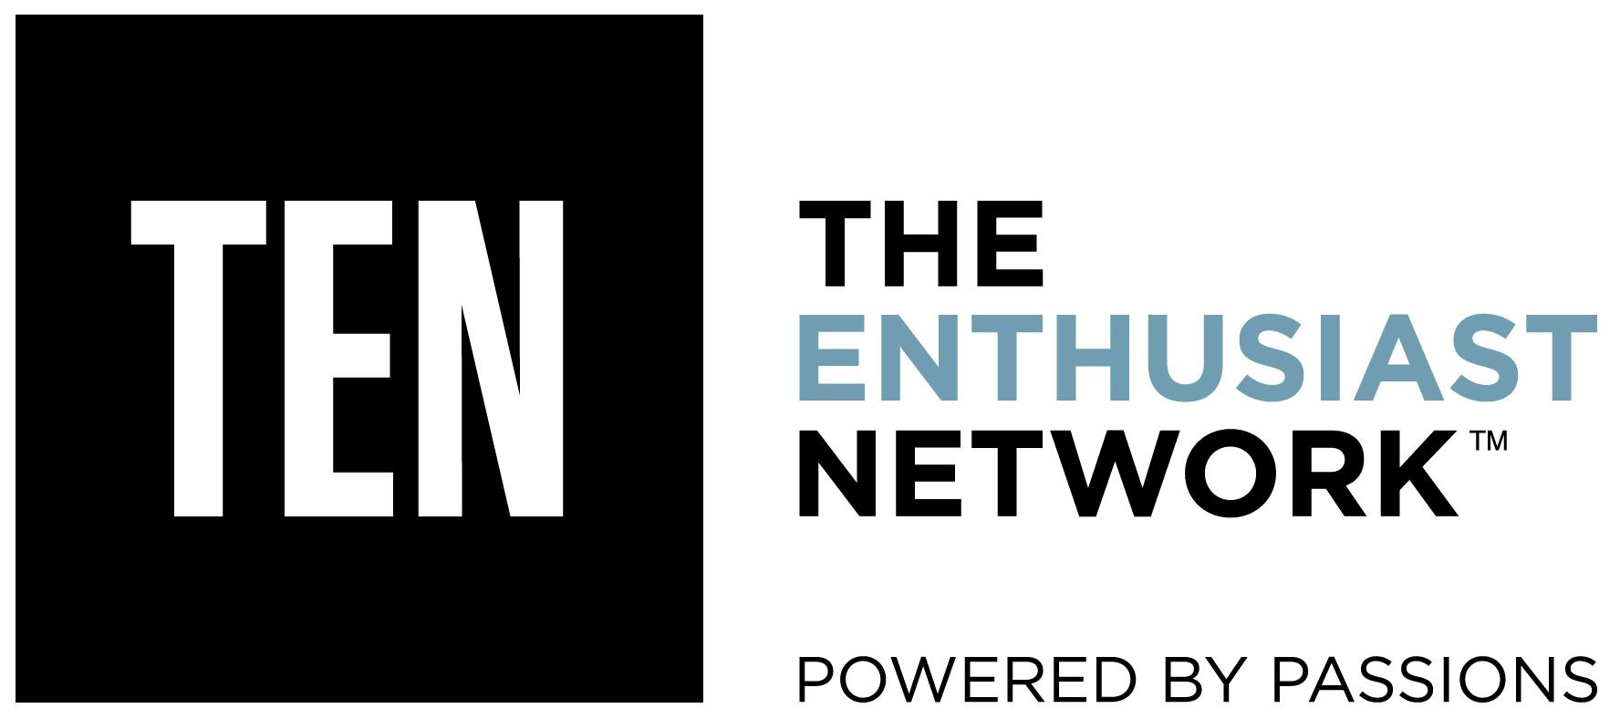

FOR IMMEDIATE RELEASE

Dew Tour Announces Action Bronson to Headline Concert at Summer Skateboard Competition in Long Beach
The Action Sports Competition & Festival Will Host an All-Star Hip-Hop Lineup During its Saturday Night Concert including Action Bronson, Kelechi and More

June 28, 2016 (CARLSBAD, Calif.)-- Mountain Dew® and TEN: The Enthusiast Network announced today that their summer skateboard Dew Tour competition and festival will be hosting an all hip-hop concert on Saturday night, July 23 at the Terrace Theatre in the Long Beach Convention and Entertainment Center. Taking center stage will be New York rapper Action Bronson to headline the concert. Also performing that night will be Atlanta-based hip hop artist and rising star Kelechi. A third act will be announced at a later time. In addition to the music, the Dew Tour will host a FREE three-day weekend celebration of skateboarding in Long Beach July 22 - 24 featuring an exciting new course and team competition as well as an individual competition, TRANSWORLD SKATEBOARDING ’s Shop Showdown, an innovative tech zone, sponsor village and a public skate park. See the full schedule here. Tickets for Saturday’s concert are now available to purchase at http://www.ticketmaster.com/event/0B0050D6A2AF29CF

Known for his wild on-stage antics and unique culinary background that he incorporates into his music and on his Viceland show, F*ck That’s Delicious, Action Bronson is a great fit for the Dew Tour, an action sports competition and content platform designed to celebrate style, creativity and progression.

Nigerian-American rapper, Kelechi, winner of the Mtn Dew Green Label Sound: Open Call competition who has been deemed by music media as a “2016 artist to watch” will be opening the show. Tackling social topics in his lyrics, he blends percussion and melodies of his parent’s homeland with the hard-hitting drums and harmonies of Atlanta’s fundamental rap sound. His sound is unique while maintaining the catchiness of your favorite southern spitter.

To view and download images and bios of both artists, click here.

For fans looking for the ultimate experience at this summer’s Dew Tour, tickets for the VIP experience are now on-sale here. VIP passes will give guests access to exclusive viewing areas that will get them up-close to all of the action, athletes and reimagined course, as well as access to all film screenings, the Saturday night concert, free food, drinks and more. For more info and to purchase VIP experience tickets, go to http://www.dewtour.com/skate/vip-pass/.

With the world’s premier trans-media network of enthusiast brands TEN: The Enthusiast Network (TRANSWORLD SKATEBOARDING, TRANSWORLD SNOWBOARDING, NEWSCHOOLERS, POWDER, SNOWBOARDER, GRIND TV) now leading the charge, the Dew Tour will have a revolutionary contest format that combines individual contests with a new team competition, highlighting creativity and style above all else. On Sunday, July 24, nine teams made up of 36 of the world’s best skaters will face off against each other. The individual competition will still be an important part of the event with individual skaters battling it out on Saturday, July 23. The summer skateboard event will kick-off with doors opening on Friday, July 22 offering the local community an opportunity to watch athletes in practice and get a first look at the sponsor village activations, the interactive tech zone, Long Beach food trucks, small businesses and more.

The Dew Tour summer skate event will be held at the Long Beach Convention Center in Long Beach, Calif. on July 22- 24. Details on Dew Tour’s upcoming winter event location and dates will be revealed in the coming months. To stay up to date on the latest content and event information coming out of Dew Tour, bookmark dewtour.com and follow on Instagram, Facebook, Snapchat, Twitter and YouTube.

Be a part of the action and join us, sign up for press credentials here.

About Dew Tour
Dew Tour is an innovative contest series and content platform that brings together the world’s best skateboarders, snowboarders, skiers, artists, brands and fans in a celebration of creativity and style.

In 2016, TEN: The Enthusiast Network, publisher of TRANSWORLD SKATEBOARDING, TRANSWORLD SNOWBOARDING, SNOWBOARDER, POWDER, NEWSCHOOOLERS, and GRINDTV became the official strategic partner to lead content production, execution and event staging for the Dew Tour. Working in close collaboration with TEN’s core action sports media brands and in partnership with DEW®, Dew Tour continues to progress events and content, bringing millions of action sports fans engaging stories and experiences across digital and broadcast mediums. In addition to Dewtour.com and TEN’s digital network, Dew Tour’s summer and winter events will be broadcast on NBC.

The Dew Tour brand believes in uplifting community, self-expression and exploring the world through the culture of action sports. Join in on the journey as the reimagined Dew Tour starts here.

About TEN: The Enthusiast Network
TEN: The Enthusiast Network is the world’s premier trans-media network of enthusiast brands, such as MOTOR TREND, AUTOMOBILE, HOT ROD, SURFER, TRANSWORLD SKATEBOARDING and GRINDTV. With more than 60 websites, 50 publications, 50 annual events, the Motor Trend OnDemand subscription video-on-demand service, as well as the world’s largest automotive and action/adventure sports media platforms, TEN inspires enthusiasts to pursue their passions. For more information, visit enthusiastnetwork.com.

Media Contact:
Melody Ann Pfeiffer
Dew Tour PR
(415) 297-9590
pfeiffermelody@gmail.com

