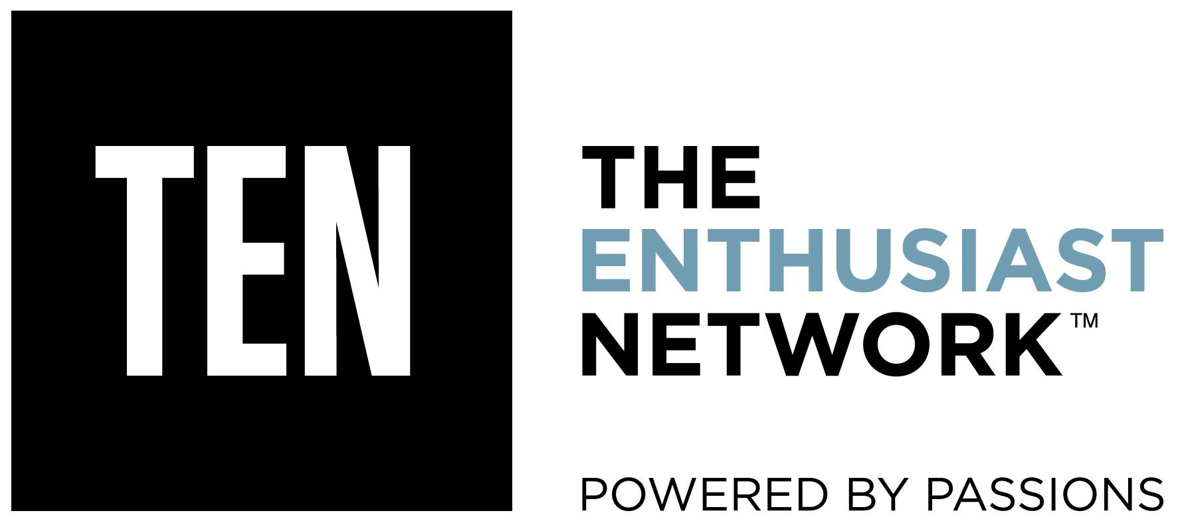

FOR IMMEDIATE RELEASE

Dew Tour To Host Brand New Summer Skateboarding Event in Long Beach, California
Reimagined Dew Tour Announces New Location, Dates and Fresh Team Format

April 20, 2016 (CARLSBAD, Calif.)-- Mountain Dew® and TEN: The Enthusiast Network made the highly-anticipated announcement today that the first stop of the 2016 Dew Tour will be held in Long Beach, Calif. on July 23- July 24, at the Long Beach Convention and Entertainment Center. There they will host a brand new skate-specific event, building on the deep history of the culture of skateboarding in Southern California.

With preeminent action sports media company TEN: The Enthusiast Network (TRANSWORLD SKATEBOARDING, TRANSWORLD SNOWBOARDING, NEWSCHOOLERS, POWDER, SNOWBOARDER, GRIND TV) now leading the charge, the Dew Tour will have a revolutionary contest format that combines individual contests with a new team competition that will highlight creativity and style above all else. The new Dew Tour has been completely reimagined to focus on more authentic stories year-round and ongoing digital content for its fans on its new site dewtour.com.

“There is so much happening in Long Beach with skateboarding right now that it felt right to host the summer event there. It is also a great centralized location for both LA and OC residents that want to experience Dew Tour,” said Adam Cozens, Vice President and General Manager, Dew Tour. “We are looking forward to collaborating with the Long Beach community to host a unique summer event that will celebrate the city’s rich history in music, arts, culture and skate.”

In addition to the new location, the contest will now feature an all-new team competition on Sunday, July 24 where nine teams made up of 36 of the world’s best skaters will face off against each other. For those traditionalists, the individual competition will still be an important part of the event with individual skaters battling it out on Saturday, July 23.

“We are excited to deliver new and progressive skate contest formats and enhanced consumer experiences at Dew Tour this year with TEN’s leadership and expertise, and Mountain Dew's continued devotion to driving progression within action sports,” said Greg Lyons, Senior Vice President of Marketing, Mountain Dew. “Our goal is to continue to celebrate skateboarding and bring the culture of the sport to life through creativity and community. Long Beach provides us with the perfect backdrop, as the city is deeply rooted in skateboarding and its lifestyle.”

“It was important to us to honor skating’s roots while still bringing something new and different to the table. The team contest was designed to celebrate the style, creativity and fun of the sport while the individual skate contest stays true to its core,” said Chris Ortiz, Dew Tour’s managing editor.

On May 3, the new dewtour.com will launch with an explosion of digital content around the new team format, course info, competing athletes and more. For now, watch DEW athlete Sean Malto skate his favorite spots in the LBC here.

TEN’s vision for the new Dew Tour has been a collaborative effort as the media company has been able to tap into its legacy action sports media brands including TRANSWORLD SKATEBOARDING, TRANSWORLD SNOWBOARDING, NEWSCHOOLERS, POWDER, SNOWBOARDER and GRIND TV to help shape authentic yet evolved summer skate and winter ski and snowboard events. The world-class competitions will be a constantly shifting action-sports platform of creativity and progression with the support of Mountain Dew, TEN and broadcast partner NBC Sports. The Dew Tour will offer exciting live experiences and captivating content for television, web, social and other digital verticals for fans around the world to enjoy.

More details on Dew Tour’s winter event location and dates will be revealed over the coming months.

About TEN: The Enthusiast Network
TEN: The Enthusiast Network is the world’s premier network of enthusiast brands, such as MOTOR TREND, AUTOMOBILE, HOT ROD, SURFER, TRANSWORLD SKATEBOARDING, and GRINDTV. With more than 50 publications, 60 websites, 50 events, 1,000 branded products, TEN delivers both the world’s largest audience in the automotive category, and the world’s largest action/adventure sports media platform. TEN inspires enthusiasts to pursue their passions. For more information, visit enthusiastnetwork.com.

Media Contact
Melody Ann Pfeiffer
Dew Tour PR
(415) 297-9590

